The Wine Cellar Reds
Product Of: Name: Type:
Niagara Falls ~ Jackson Triggs: ~ Merlot
Velvety texture with bouquet of berries & herbs, serve with beef, Veal & pork
Glass $6.50 ½l $18
Niagara Peninsula ~ Wayne Gretzky ~ Merlot
2007 rounded palate with moderate tannins Fruity with a mocha & oak finish
Bottle $31
Niagara Peninsula ~ Dan Aykroyd ~ Cabernet Shiraz
2006 Forest fruit flavours with a peppery note from the shiraz, serve with bbq meats & pastas
Bottle $33
Lake Erie North ~ Girl’s Night Out ~ Merlot
2006 Silky & smooth with blackberry jam & spice, serve with grilled beef, pasta & good friends
Glass $6.25 Bottle $26
Hopeland California ~ Little Black dress ~ Merlot
2006 Soft berry & tannins, A sophisticated understated Merlot. Like your little black dress
Glass $6.50 Bottle $30
Chili ~ Gato Negro ~ Cabernet
2007 Vibrant ruby red, medium bodied with berry fruit, soft tannins, serve with spiced meat
Glass $5.75 Bottle $22
Argentina ~ Argento ~ Malbec
2007 Superb Malbec, powerful aromas of fruit & chocolate lead into a lingering finish of velvety tannins.
Glass $6 Bottle $24
Australia ~ BIN 444 ~ Cabernet Sauvignon
2005 Classic with Generous blackcurrant & cassis flavours complemented by soft tannins
Glass $6.75 Bottle $31
South Australia ~ BIN 555 ~ Sparkling Shiraz
Selected full flavoured Shiraz grapes are utilised The style shows aromas of rich berry fruit with lifted Shiraz spice. Subtle yeast complexity & light vanilla oak are evident. A medium to full weight with soft tannins
Bottle $33
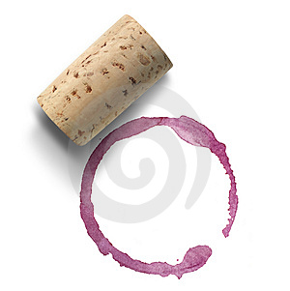
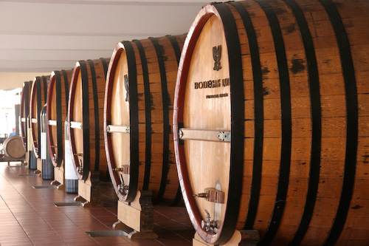
The Wine Cellar Whites
Niagara Falls ~ Jackson Triggs: ~ Sauvignon Blanc
Distinctive floral bouquet which is complemented by notes of citrus & dill with a elegant finish serve with seafood & grilled vegetables
Glass $6.25 ½l $17
Lake Erie North ~ Girl’s Night Out ~ Chardonnay
2007 Elegant & dry, this VQA delivered creamy citrus & butterscotch notes, serve with grilled vegetable seafood & chicken
Glass $6.25 Bottle $26
Australia ~ BIN 222 ~ Chardonnay
2006 rich & generous melon & peach flavours complemented by a soft finish. Served with lightly spiced foods as well as light meat & pasta dishes.
Glass $6.50 Bottle $26
New Zealand ~ Stoneleigh ~ Sauvignon Blanc
2007 intense bouquet of passion fruit & grapefruit with background mineral notes. The palate adds a burst of ripe stone fruit, serve with seafood & fish
Glass $6.50 Bottle $34
Premium Liquors
Tequila Rose Malibu Rum
Hypnotic Grey Goose Vodka
Drambuie Glenfiddich Scotch
Southern Comfort Appleton’s spiced rum
Goldschlager Captain Morgan’s spiced rum
Jagermeister Bacardi Gold rum
Sambuca Corkies white vanilla
Grand Marnier Jack Daniels
Disaronno Crown Royal
Tequila Kahalua
Brandy Carolans
Frangelico Long island
Beverages
Aquafina $2.50 ~ Perrier $3.50
2% milk $2.25 ~ Chocolate Milk $2.50
Virgin Pina collada $3.50
Virgin Strawberry daiquiri $3.50
Shirley temple $3.50
Soft Drinks $2.50 bottomless with food purchase
Pepsi ~ Diet Pepsi ~ 7UP ~ Ginger Ale ~ Ice Tea
Coffee $1.95 ~ Tea $1.95
Specialty Tea $2.50
Hot Chocolate $2.00
Gourmet hot chocolate $3.25

