
NATURE’S HAVEN
PARKLAND DEVELOPMENTS

o/a 1679410 Ontario Inc. (Nature’s Haven Subdivision)

4591 St-Michel Street, Hanmer, Ontario P3P 1M8
Phone: (705) 969-7215 www.natureshaven.ca

MODEL HOME SELECTION GUIDE – APRIL 23, 2009

The model homes contained in this guide come with the following standard features as per their respective plans. Where indicated, appropriate allowance totals are included in the purchase price for each model. Any extra cost for additional enhancements will be added to the list price of the model.

EXTERIOR: The Purchaser will be able to select from a variety of brick or stone finishes provided by the builder for the entire front of the house, and select from a choice of massonite staccato finishes for the sides and back of the house. | LANDSCAPING: The front and sides of each home will be fully landscaped with sod. Sod will be put in to a distance of 20 feet or less from the back of the house. A deck will be built off the patio door at the back of the house with gas hookup and electrical for hot tub. | FOUNDATION: Insulating concrete forms (ICF) with minimum R 36 insulting value will be used for the foundation as well as the above-grade walls up to the roof. All concrete flooring in the basement will include in-floor radiant heating.
BASEMENTS: Fully finished basement with three piece standard bathroom, laundry room, laminate flooring, and painting of your choice. | PAINTING: All rooms will be painted with a latex primer and a choice of colours to be selected by the purchaser as made available by the builder. | CEILINGS: Custom textured ceilings in all rooms except for bathrooms, kitchen and utility rooms.
GARAGE: Fully finished garage with R-50 insulation in ceiling, painted walls complete with thermally insulated garage doors and electric garage door opener. | BATHROOMS: An allowance will be provided to enable the purchaser to select tubs, sinks, vanities, fixtures, ceramic tile, etc. as per the plan. | KITCHEN: An allowance will be provided to enable the purchaser to select and install their choice of attractive and functional cabinets.
FLOORING: An allowance will be provided that will enable the purchaser to finish the floors with ceramic tiles in the entrances, kitchen and bathrooms. 12 mil laminate throughout the remainder of the house. | WINDOWS & DOORS: The purchaser will be able to select from a variety of top quality windows and doors provided by the builder. | HEATING: All houses will be equipped with a geothermal heating system as well as a forced air gas furnace and a 200 Amp electrical system for your choice of heating alternatives.
CENTRAL AIR: All homes come complete with high quality central air conditioning. | CENTRAL VACUUM: All homes come complete with a high quality central vacuum cleaning system. | GAS FIREPLACES: All homes come with a gas fireplace in a room to be selected by the purchaser
BASEMENT BATHROOM: Extra three-piece bathroom included in finished basement. | ENSUITE BATHROOM: Master bedroom comes complete with ensuite bathroom. | WALK-IN CLOSET: Master bedroom comes complete with walk-in-closet.
LOT SELECTION: Lots #4, 5, 6, 7, 8, 9, 10, 31, 32, and 33 are approximately 10,500 square feet in area
SEE DIAGRAM Lots #1, 2, 3, 11, 12, 13, 18, 19, 20, 21, 22, 23, 28, 29, 30 are between 13,500 and 15,000 square feet 14,268 sq. ft. in area
BELOW Lots #14, 17, 24, 27 are approximately 18,600 square feet in area (add a premium of $10,000 to list price)
Lots #15, 16, 25, 26 are approximately 21,780 sq. ft ( ½ acre in area) (add a premium of $20,000 to the list price)
For all lots backing onto greenbelt: add a premium of $10,000
Although the Information displayed on the following pages is believed to be accurate, no warranties or representations are made of any kind.
G.S.T is included in the price with the buyer to sign back rebate.
Listing photos are artist renditions only and the home may not be built exactly as shown.
Nature’s Haven will do its best to ensure that there are no two houses in the subdivision that are exactly alike. Each model in this book will only be used once.
LOT SELECTION
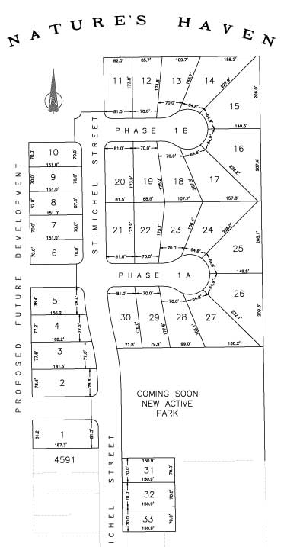
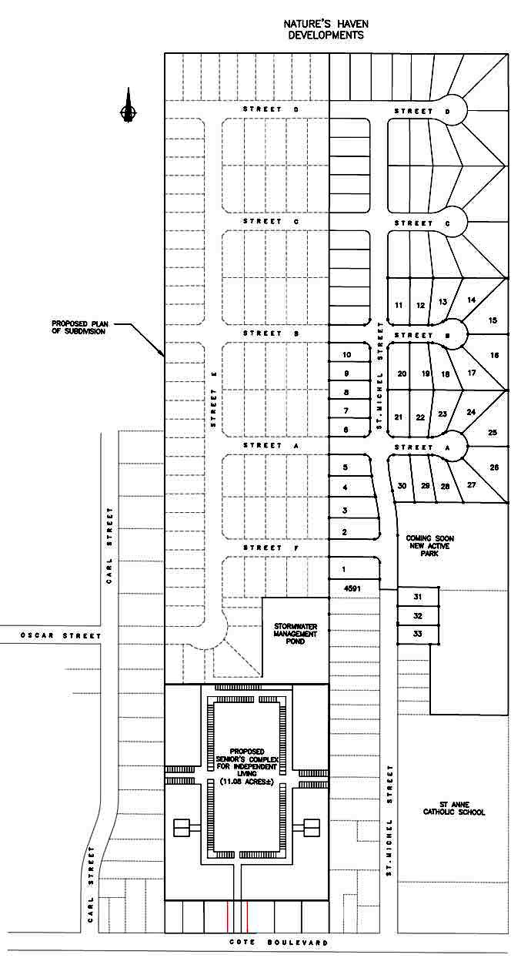

FOUNDATION & EXTERIOR WALLS

Nature’s Haven Custom Built Homes will be constructed with radiant-heated floors, draft-free walls, larger windows and wider open spaces.

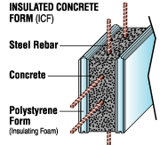
WALLS
The walls are made with insulating concrete forms (ICF) which are hollow "blocks" or "panels" made of high insulated polystyrene.
They are stacked like building blocks to form the outside walls of the structure.
Reinforcing steel is added and concrete is poured into their hollow cavity.
Together these well-known construction materials create a wall system that offers superior insulation and solid construction. And similar to today's children's construction sets, the design of homes using ICF is only limited by your imagination.

FLOORS
Warm water circulates through durable plastic tubing safely embedded in the concrete floor.
In addition to warmth, concrete floors give you the flexibility to design wider, more open spaces than ever before.
Together, infloor radiant heat with concrete floors provide even temperatures, a healthier living environment, design flexibility, and overall comfort.
The result is a more comfortable, cost-effective, energy-efficient heating system.
Radiant heat will allow you to maximize the utilization of your basement level.

ICF- Insulating Concrete Forms
Advanced Building System For Your New Home
The Features | The Benefits
More Energy Efficient | Save 40% on heating bills
Virtual Dust and Pollen Free | Healthier living
Reduced Sound transmission | Comfort, privacy
Larger Windows, bigger floor spans | Flexibility in building
Wide window sills | Versatile interior decoration
Sound resistant, quiet floors system | Peace and quiet
In floor Radiant Heating | Warm floors, consistent temperatures
Resistant to harsh weather storms | Safe and secure
Fast, year round construction | Convenient construction schedules
Superior Insulation value | Consistent temperature through entire house
GEOTHERMAL ENERGY SYSTEM

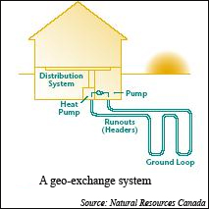
Nature’s Haven Custom Built Homes will include geoexchange systems that use geothermal energy, the energy that is naturally stored as heat in the earth's surface. The earth's surface under the frost line maintains a nearly constant temperature between 10° C and 16° C (50° F and 60° F), remaining warmer than the air above it in the winter and cooler in the summer.

A geoexchange, or geothermal heat pump, system takes advantage of this constant temperature by transferring heat stored in the earth or in ground water into a building during the winter and transferring it out of the building and back into the ground during the summer. The ground acts as a heat source in winter and a heat sink in summer.

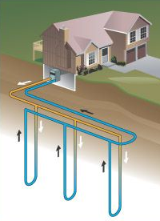
A geoexchange system consists of three main parts:
- pipes buried in the ground,
- a heat exchanger, and
- ductwork to distribute heat into the building.
The series of pipes, commonly called a "loop," is buried in the ground, vertically near the building.
During the winter months, the loop circulates water, or a mixture of water and antifreeze,that absorbs heat from the surrounding soil. Heat is then removed from the fluid, concentrated in the heat exchanger and transferred to the building.
This process is controlled by a heat pump that regulates the temperature level.
During the summer the process is reversed and, in essence, the system works like an air conditioner.
In addition to space conditioning, a geoexchange system can provide hot water heating, using a "desuperheater," which transfers excess heat from the heat pump's compressor to the building's hot water tank. This is very common in residential geothermal heat pump applications.
Some of the tremendous benefits of having a geoexchange system in Nature’s Haven Custom Built Homes are explained on the following page.

BENEFITS OF A GEOTHERMAL SYSTEM
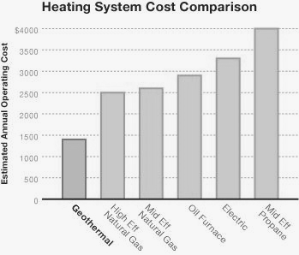
- A geothermal system operates more efficiently than ordinary heating and air conditioning systems because it can deliver four units of energy for every one unit of electrical energy used. That translates into an efficiency rating of 400 per cent, compared to the most efficient gas furnace, which rates only 94 per cent. By combining stored energy with safe electric power, many homeowners realize savings up to 60-70% for heating, cooling and hot water.
- Because of the extraordinary efficiency of a geothermal system, any added investment related to installing a geothermal unit is more than offset by your energy savings. In new homes, most homeowners will experience an immediate positive return on their investment when the system cost is added to the mortgage. And with a long system life and less maintenance, overall life cycle costs are lower with geothermal.
- Geothermal systems are the most environmentally friendly way to heat and cool your home. The system emits no carbon monoxide or other greenhouse gasses which are considered to be major contributors to environmental air pollution. With a geothermal system, you can take comfort in a better environment. In addition, the lower peak demand for geothermal systems helps to postpone the need to build more expensive electric generating plants.
- A geothermal system provides precise distributing of comfortable air all year long, eliminating hot spots and cold spots. During heating, you'll experience warm air without the hot blasts associated with ordinary gas furnaces. And compared to an air-source heat pump, the air is warmer. When cooling, a geothermal unit delivers cool, dehumidified air.

STANDARD FEATURES & FINISHES

Nature’s Haven Custom Built Homes provides you with a custom touch to exceed the toughest of industry standards. We are committed to providing you with peace of mind and a beautifully constructed home in the distinctive Nature’s Haven Parkland Subdivision on a lot of your choice and size. We would like to customize your new home and make it as unique as your lifestyle. That is why we will do everything we can to ensure that no two homes are alike in the subdivision and also why we are going to provide you with the maximum flexibility in selecting the styles and materials you wish in the construction of your home. We will be allowing you to select the features and finishes for some of the major elements of your home from our preferred suppliers. In many cases we will give you an allowance that will allow you to select some of the finest quality of products on the market without having to increase expenditures. Nevertheless, if it is your wish to enhance your home with some of the more expensive products available, you will simply need to pay the difference between the allowance and the actual cost.

The following items are included in the purchase price and are subject to amendment upon mutual agreement.

EXTERIOR
- Insulating Concrete Form (ICF) block foundation with a minimum insulation value of over R-36
- Exterior walls with rubberized membrane damp proofing material as well as weeping tiles
- Attic to be a minimum of 13 inch cellulose with an R-50 insulation value
- Engineered roof trusses and/or conventional framed roof structure as per plan requirements
- Tongue and groove high performance top notch sub flooring with 50 year transferrable warranty that is screwed and glued down to floor joists
- Brick or stone on the entire front of building with style to be selected from builder’s samples
- Masonite staccato on all other sides and rear of house to be selected from builder’s samples
- Superior Quality window and door package allowance to be provided to the purchaser and installed by builder
- Maintenance free soffits, fascia & eaves trough and downspouts selected from builder’s samples
- 25 year architectural shingles to be selected from builder’s samples
- Sodding will be done in the front yard and side yards as well as in the back yard up to 20 feet behind the rear of the house (from June to Sept)
- Address stone installed on the front of the house
- Precast stone window sills
- Exterior lights and lighting as per plan
- Driveway to consist of crushed stone
- Exterior deck of up to 200 square feet will be built outside patio door or against the rear of house at a spot selected by purchaser
- Precast concrete (patio stone) walkway from driveway to front entrance
- Four exterior hose facets located in the garage, on both sides and in the rear of the house
- Roughed in piping to deck area for exterior gas barbecue

INTERIOR

- Choice of designer ceramic tiles in foyer, kitchen, bathrooms and laundry areas
- 12 mil high end laminate flooring in all other areas of the house
- Main floor stairs and railing will be oak or maple stained from builder’s samples if plan permits
- Colonial baseboards and trim for doors and window casings to be selected from builder’s samples
- 9 foot ceilings throughout unless plans call for something different
- Closet doors selected from builder’s samples
- Doors and trim to be painted white
- Interior doors selected from builder’s samples
- All walls to be finished with latex primer and purchaser’s choice of colours from builder’s samples
- Custom textured ceilings (except for kitchen, bathrooms, and utility rooms)
- Vertical edges to have rounded drywall corners.
- Interior hardware package chosen from builder’s samples
- Bulkheads, knee walls and other horizontal edges to have round drywall corners

BASEMENT

- Poured concrete floors complete with machine-towelled finish
- Radiant Heating in basement floor
- Fully finished basement with three piece bathroom as per attached plan
- Floor drain, sump pit and pump to be installed in an appropriate location (laundry room if possible)
- Water meter installed

GARAGE

- Poured concrete floor with polished finish
- Thermally insulated garage door(s) with electric door opener (to be selected from builder’s samples by purchaser)
- Walls to be drywalled and painted with latex primer and two coats of white paint
- Floor drain installed
- Ceiling will be installed in garage with R-50 insulation in the attic area if plan allows

KITCHEN
- Generous kitchen cabinet allowance to be provided to the purchaser
- Choice of laminate countertop
- Double stainless steel sink with single lever faucet
- Exterior vented hood fan over stove
- Rough-in for electrical and water pipe for future built-in dishwasher
- Water line installed with shut off valve for fridge in kitchen
- Microwave shelf with electrical outlet if plan permits

BATHROOMS

- Privacy locks
- Green board reinforced tub and shower walls
- Positemp pressure/temperature balance valves for showers
- Ground fault interrupter
- Bathroom vanity, tub, and shower allowance to be provided to the purchaser

LAUNDRY ROOM

- Laundry tub where plan permits
- Finished laundry room
- Hot and cold laundry taps
- Exterior vented dryer for either gas or electrical
- Laundry wall mount in main floor laundry room if plan permits

TECHNOLOGY ROUGH-INS

- Pre-wiring for internet and phone (kitchen, great room, all bedrooms and basement)
- Pre-wiring for television with high end coaxial cable (great room, living room, all bedrooms and basement)
- Pre-wiring for security system
- Pre-wiring to exterior deck for future hot tub use

ELECTRICAL, PLUMBING AND HEATING

- High efficiency forced air gas furnace installed in basement
- Geothermal heating system installed in basement
- Central air conditioning
- Central vacuum installed in garage with minimum of one outlet on each floor including basement.
- Gas fireplace will be installed in a room where plans permit to be selected by the purchaser
- Decorative ceiling light fixtures selected from builder’s samples
- White décor light switches throughout
- Switch controlled wall outlet in Living Room or Great Room
- Bedroom outlets connected to an arc fault breaker as per code
- Three exterior G.F.I. outlets (front, rear and on the garage side)
- Exterior soffit plug with switch for holiday lighting
- Bell chime for front entrance
- Both Electrical wiring and gas line installed for stove and dryer
- Rental hot water tank or rental hot water on demand (to be determined by purchaser)
- Copper wiring
- Shut off valves for all sinks
- Plastic water lines throughout
- Heat recovery ventilator (HRV) complete with controls in bathroom
- 200 AMP electrical service with circuit breakers
- Hard wired smoke detectors on each floor (including basement)
- Hard wired carbon monoxide detectors on each floor (including basement)
- Dedicated electrical outlets for refrigerator. Split outlets at counter level for small appliances

VALUE-ADDED BENEFITS OF PURCHASING A HOME IN NATURE’S HAVEN PARKLAND DEVELOPMENTS

- Each house in the subdivision will be unique. The builder will not allow two purchasers to build identical houses with the same exterior finish on the front.
- You can select from over thousands of plans provided by Nature’s Haven or you can bring in your own design.
- The lots are much larger than normal. You can select lots that range from 10,500 to 21,780 square feet. Lots range from 64 to 82 feet wide at the front and from 70’ to 205’ wide at the back. Lots range from depths of 151’ to 232’ You will have plenty of yard remaining after you build your house.
- Each house is constructed with Insulating Concrete Form blocks for the foundation and entire side walls up to the roof. This energy efficient construction will save up to 50% of your energy costs in both winter and summer.
- Each house is being equipped with both a forced air gas furnace and a geothermal heating system.
- Each house has radiant heating in the basement floors to add to your comfort.
- Each house comes with central air conditioning.
- Each house comes with a central vacuum cleaner.
- Each house will have top quality, attractive brick or stone from ground to roof on the front and masonite staccato on the sides and back.
- Each house will have a fully finished basement with an extra three-piece bathroom and laminate flooring.
- The walls in the garage will be covered with drywall and painted along with a R-50 insulated ceiling and automatic garage door opener.
- Not only will the front and sides of your house be landscaped with new sod, but we will landscape up to 20 feet behind your house with sod as well. We will leave the rest of your property in its natural state. You will also have a deck of 200 square feet installed outside your patio door.
- Each room in your house will be completely painted with your choice of colours. This means that you can simply move in your furniture upon closing with little or no preparation.
- You will have a generous allowance with which to select your exterior windows and doors; kitchen cabinets; bathroom tub, shower, vanity and fixtures; and all of your flooring.
- You will be able to supervise the entire construction from start to finish. We will provide you with a tour at any time as long as you call in advance so that we can have someone ready to take you through the house.
- The builder actually lives in the subdivision and will be readily available should there be any problems that are covered under the seven year Tarion Warranty,
- Your home is being built for the future with many energy saving features. This means that your home will have a high resale value should you ever decide to sell it in the future.
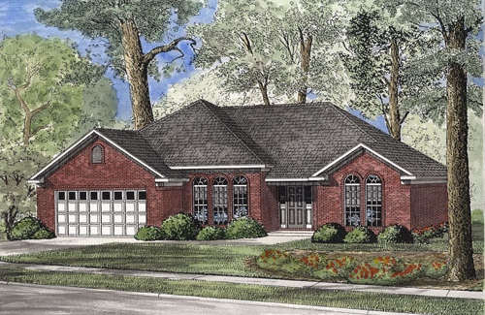
TRADITIONAL
PLAN 25-556

1763 square feet
3 bedrooms
2 bathrooms
Double garage
Width 56 feet
Depth 52 feet

Price

$429,000
Lot Size: 82’ x 174’
14,268 square feet

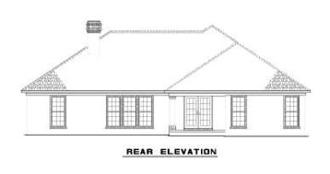

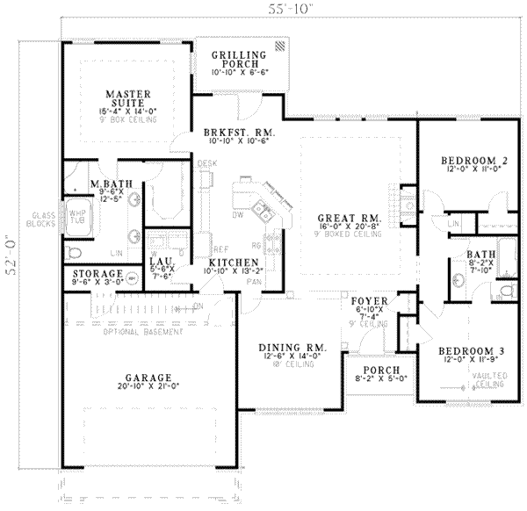
FEATURES
- storage area
- split bedrooms
- great room/living room
- covered rear porch
- volume/vaulted ceiling
- peninsula/eating bar
- walk-in closet
- nook/breakfast area
- dining room
- open floor plan
- full basement

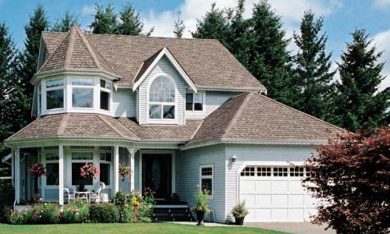
VICTORIAN
PLAN 47-285

2301 square feet
4 bedrooms
2 1/2 bathrooms
Double garage
Width 48 feet
Depth 53 feet

Price

$469,000
Lot size: 82’ x 174’
14,268 square feet

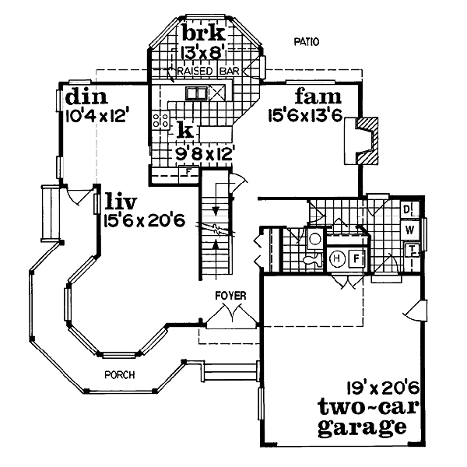
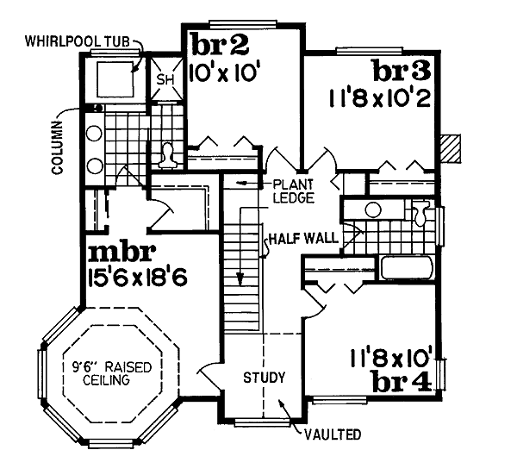

FEATURES  - wrap around porch  - loft / balcony  - upstairs master bdrm  - suited for view lot | - kitchen island  - walk-in closet  - suited for narrow lot  - family room/keeping room  - nook/breakfast area/dining

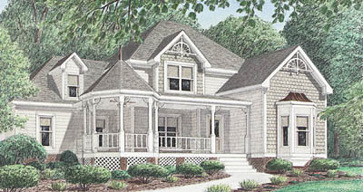
VICTORIAN
PLAN 34-111

2044 square feet
3 bedrooms
2 1/2 bathrooms
Double garage
Width 56 feet
Depth 45 feet

Price

$429,000
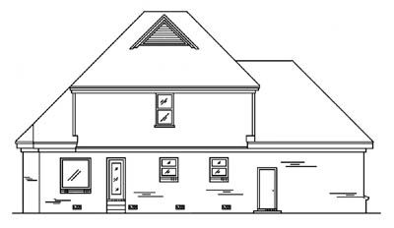
Lot size: 82’ x 174’
14,268 square feet

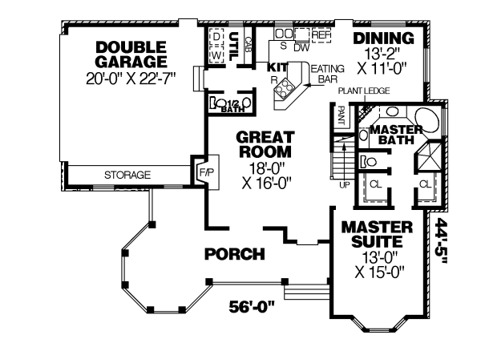
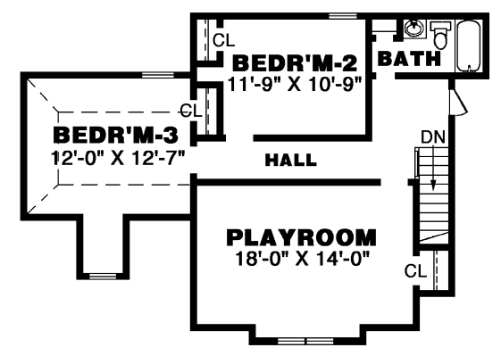

FEATURES
- great room/living room
- suited for view lot
- kitchen island
- covered front porch
- storage area
- walk-in closet
- main floor master bed & bath
- peninsula/eating bar
- side-entry garage
- family room/keeping room
- suited for corner lot
- open floor plan
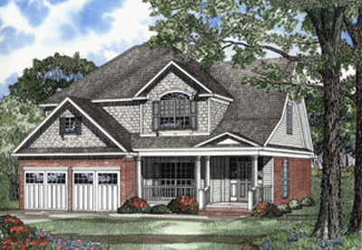
CRAFTSMAN
PLAN 25-437

2244 square feet
4 bedrooms
2 1/2 bathrooms
Double garage
Width 42 feet
Depth 56 feet

Price

$459,000
Lot size: 82’ x 174’
14,268 square feet

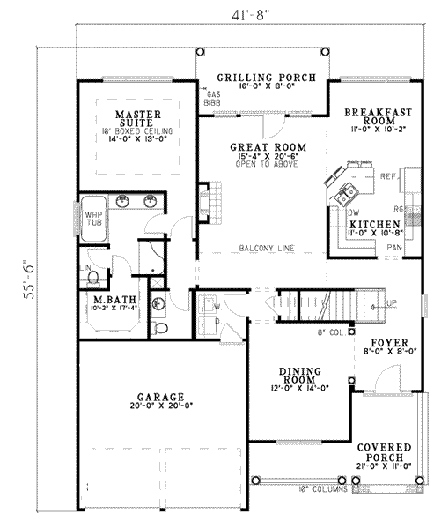
FEATURES
- great room/living room
- loft / balcony
- suited for view lot
- covered rear porch
- covered front porch
- walk-in closet
- volume/vaulted ceiling
- main floor master bed & bath
- peninsula/eating bar
- teen suite/Jack & Jill bath
- nook/breakfast area/dining

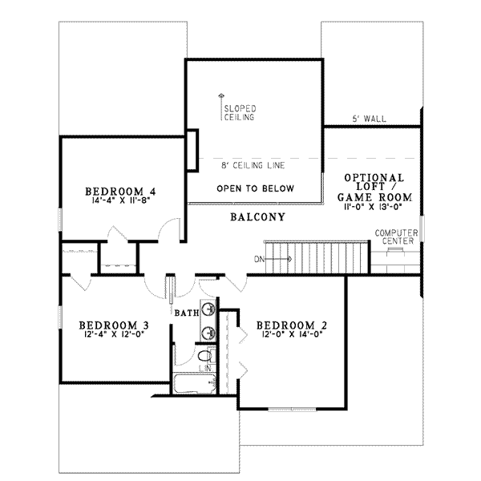

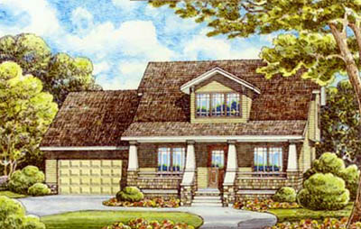
COUNTRY
PLAN 38-102

1558 square feet
3 bedrooms
2 bathrooms
Double garage
Width 45 feet
Depth 49 feet

Price

$359,000
Lot size: 82’ x 174’
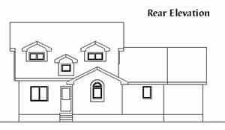
14,268 square feet

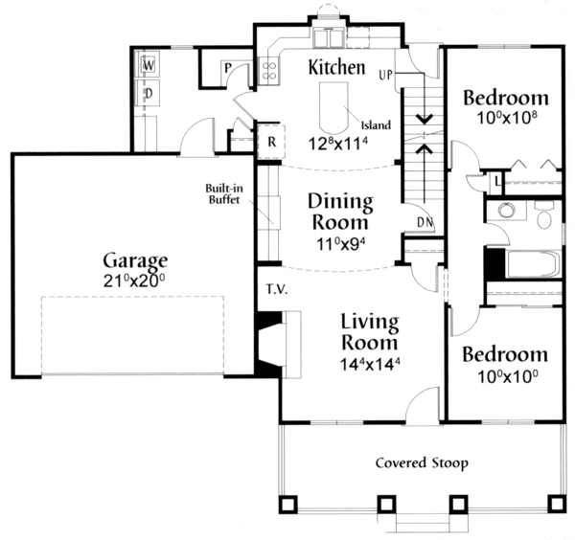

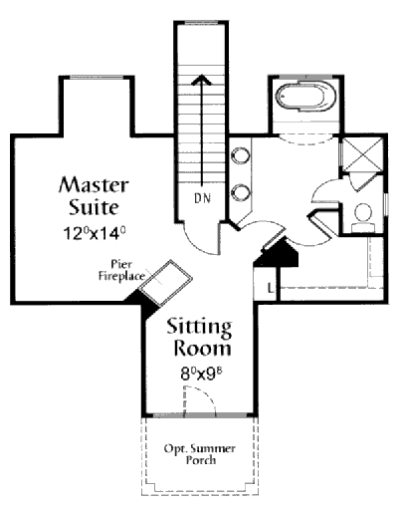
FEATURES
- great room/living room
- upstairs master bdrm
- kitchen island
- peninsula/eating bar
- covered front porch
- split bedrooms
- walk-in closet
- master sitting area
- butler's pantry
- suited for narrow lot
- suited for corner lot
- open floor plan
- walk-in pantry/cabinet pantry
- daylight basement

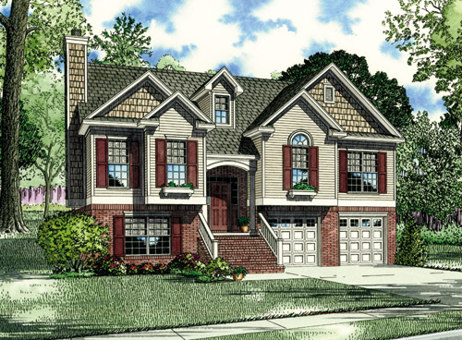
EUROPEAN
PLAN 25-343

1596 square feet
3 bedrooms
3 bathrooms
Double garage
Width 45 feet
Depth 41 feet

Price

$359,000
Lot size: 82’ x 174’
14,268 square feet

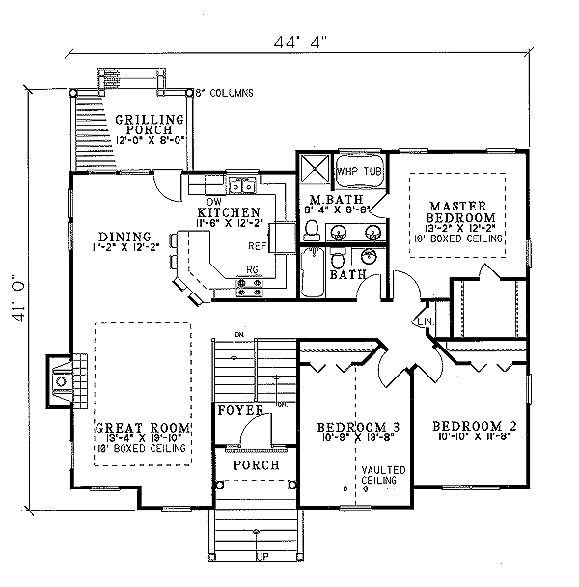

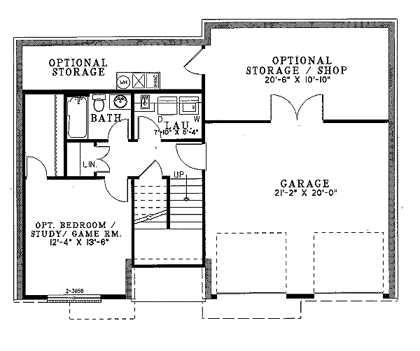
FEATURES
- great room/living room
- upstairs master bdrm
- covered rear porch
- storage area
- unfinished/future space
- walk-in closet
- suited for sloping lot
- volume/vaulted ceiling
- workshop
- peninsula/eating bar
- garage under
- suited for narrow lot
- open floor plan
- daylight basement

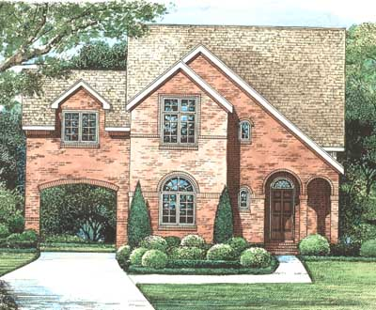
EUROPEAN
PLAN 15-1224

1728 square feet
3 bedrooms
3 bathrooms
Double garage
Width 42 feet
Depth 49 feet

Price

$379,000
Lot size: 82’ x 174’
14,268 square feet

FEATURES OF THE HOME (FLOOR PLAN ON NEXT PAGE)
- covered front porch  - unfinished/future space  - great room/living room  - upstairs master bdrm  - breezeway | - peninsula/eating bar  - volume/vaulted ceiling  - guest suite  - suited for narrow lot  - detached garage | - bonus/play/flex room  - rear garage  - open floor plan  - unlimited use

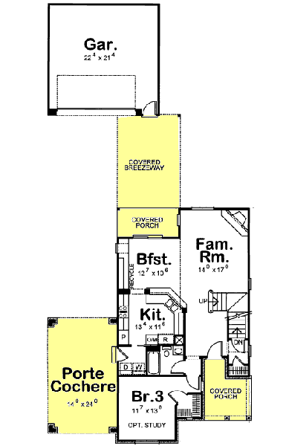
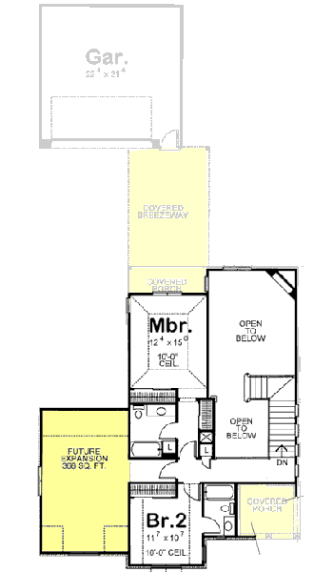

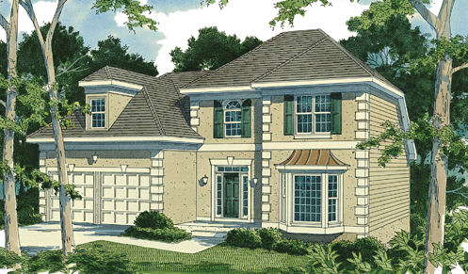
EUROPEAN
PLAN 20-119

1835 square feet
3 bedrooms
2.5 bathrooms
Double garage
Width 45 feet
Depth 42 feet

Price

$399,000
Lot size: 82’ x 174’
14,268 square feet

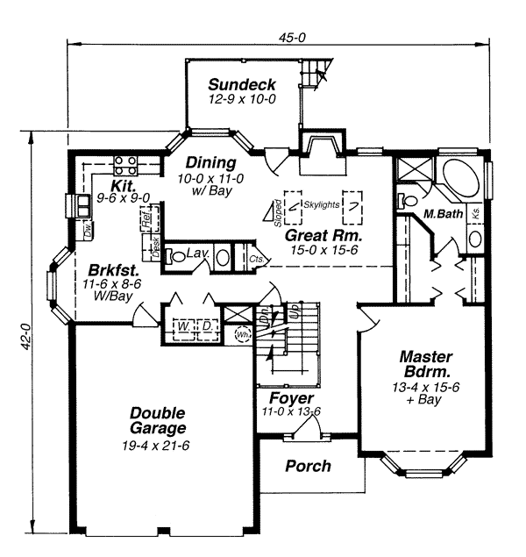
FEATURES
- bonus/play/flex room
- main floor master bed & bath
- suited for narrow lot
- walk-in closet
- unfinished/future space
- nook/breakfast area/dining
- storage area
- volume/vaulted ceiling

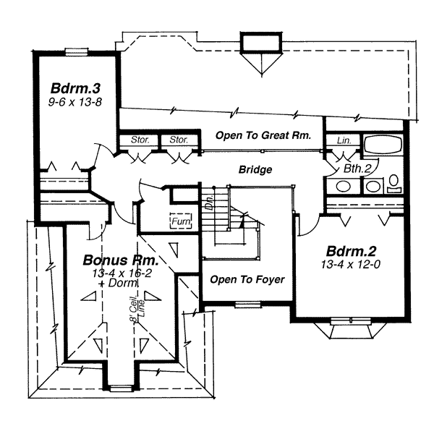

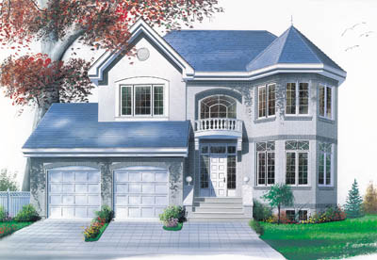
EUROPEAN
PLAN 17-165

2030 square feet
3 bedrooms
2.5 bathrooms
Double garage
Width 45 feet
Depth 36 feet

Price

$429,000
Lot size: 82’ x 174’
14,268 square feet

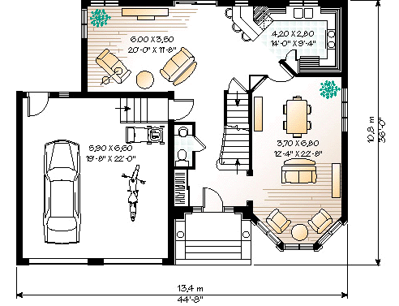

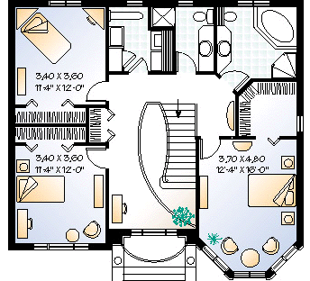
FEATURES
- upstairs master bdrm
- walk-in closet
- peninsula/eating bar
- upstairs laundry
- suited for narrow lot
- family room/keeping room
- daylight basement

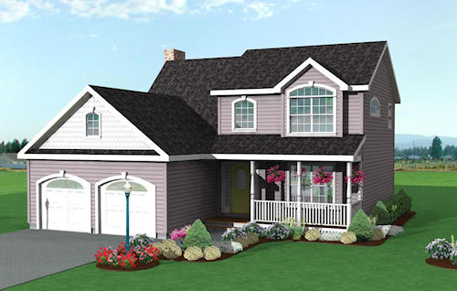
TRADITIONAL
PLAN 29-21

1521 square feet
3 bedrooms
2.5 bathrooms
Double garage
Width 41 feet
Depth 39 feet

Price

$349,000
Lot size: 82’ x 174’
14,268 square feet

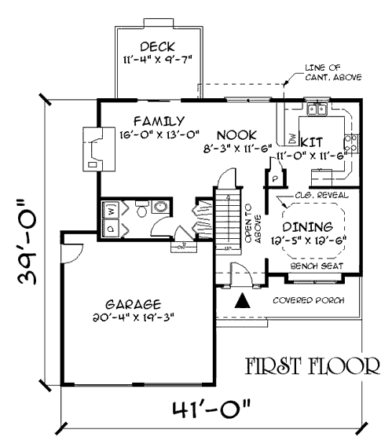
FEATURES
- great room/living room
- upstairs master bdrm
- walk-in closet
- suited for narrow lot
- nook/breakfast area/dining
- open floor plan

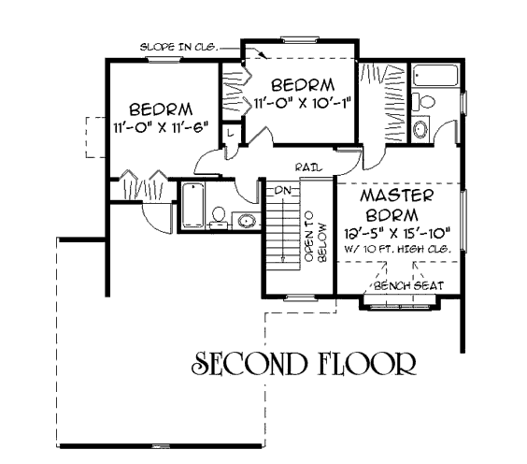

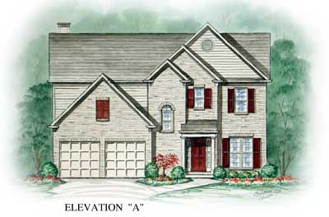
TRADITIONAL
PLAN 54-144

1714 square feet
3 bedrooms
2.5 bathrooms
Double garage
Width 42 feet
Depth 38 feet

Price

$379,000
Lot size: 82’ x 174’
14,268 square feet

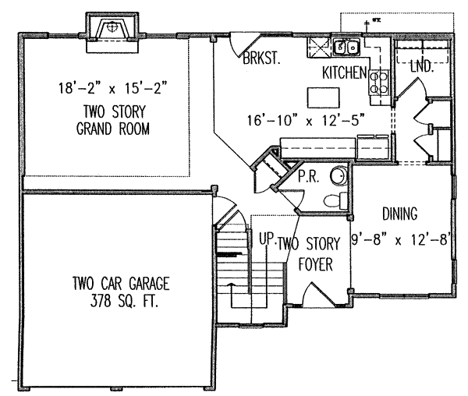
FEATURES
- great room/living room
- upstairs master bdrm
- kitchen island
- volume/vaulted ceiling
- walk-in closet
- suited for narrow lot
- nook/breakfast area/
- dining room
- open floor plan

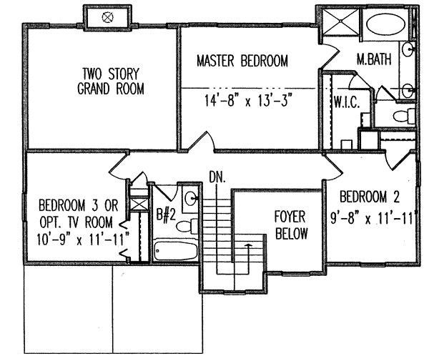

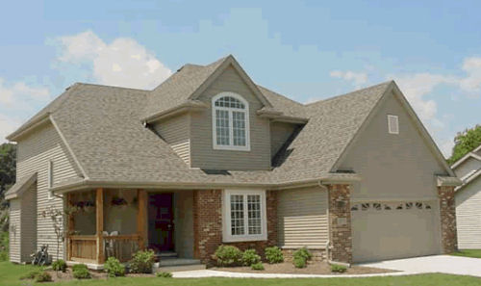
TRADITIONAL
PLAN 15-177

1776 square feet
4 bedrooms
2.5 bathrooms
Double garage
Width 44 feet
Depth 40 feet

Price

$389,000
Lot size: 82’ x 174’
14,268 square feet

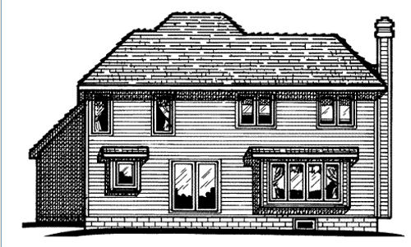

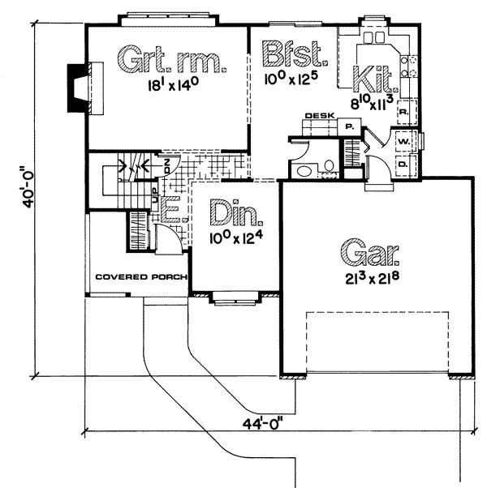
FEATURES
- upstairs master bdrm
- unlimited use
- suited for view lot
- walk-in closet
- suited for narrow lot
- nook/breakfast area/dining
- open floor plan

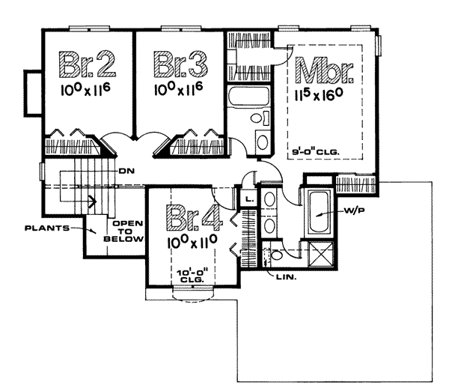

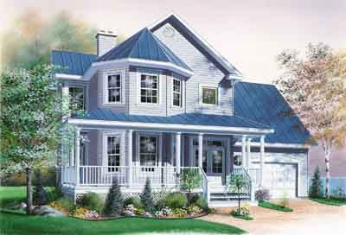
COUNTRY
PLAN 17-135

1760 square feet
3 bedrooms
2.5 bathrooms
Single car garage
Width 42 feet
Depth 40 feet

Price

$384,000
Lot size: 82’ x 174’
14,268 square feet

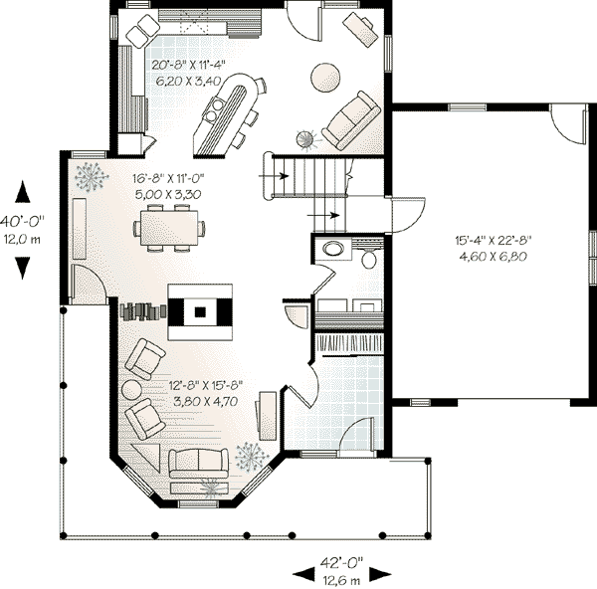
FEATURES
- storage area
- upstairs master bdrm
- kitchen island
- unfinished basement
- walk-in closet
- peninsula/eating bar
- bonus/play/flex room
- nook/breakfast area/dining

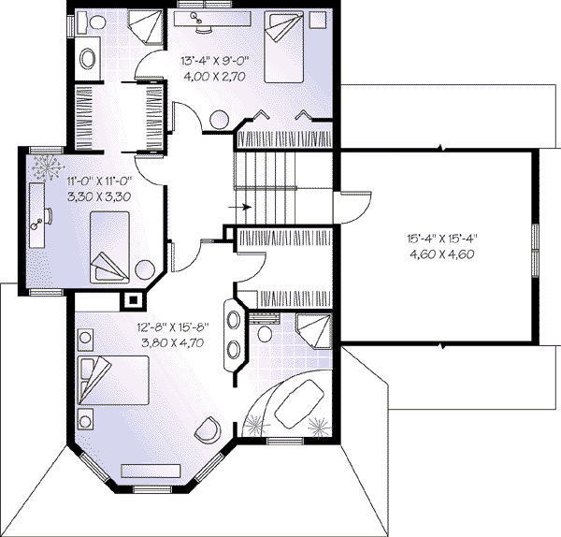

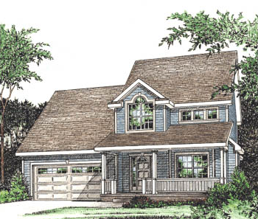
COUNTRY
PLAN 15-651

1518 square feet
3 bedrooms
2.5 bathrooms
Double car garage
Width 45 feet
Depth 59 feet

Price

$349,000
Lot size: 82’ x 174’
14,268 square feet

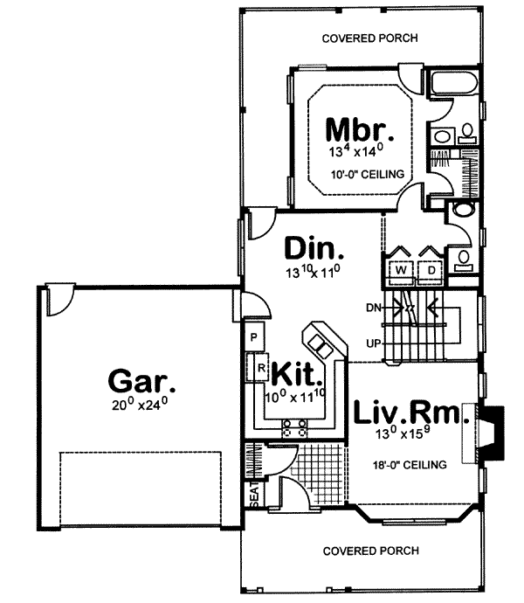
FEATURES
- loft / balcony
- covered rear porch
- unfinished basement
- suited for narrow lot
- bonus/play/flex room
- peninsula/eating bar
- volume/vaulted ceiling
- main floor master bed & bath
- covered front porch
- unfinished/future space
- walk-in closet
- unlimited use

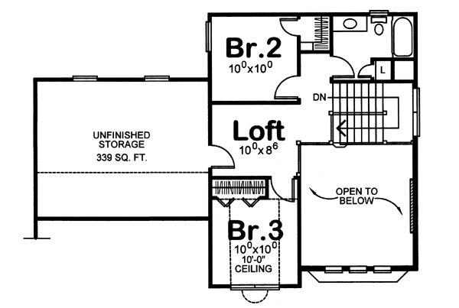

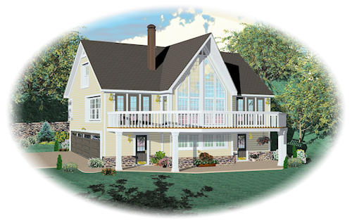
CONTEMPORARY
PLAN 81-13783

1532 square feet
3 bedrooms
3 bathrooms
Double car garage
Width 44 feet
Depth 47 feet

Price

$349,000
Lot size: 82’ x 174’
14,268 square feet

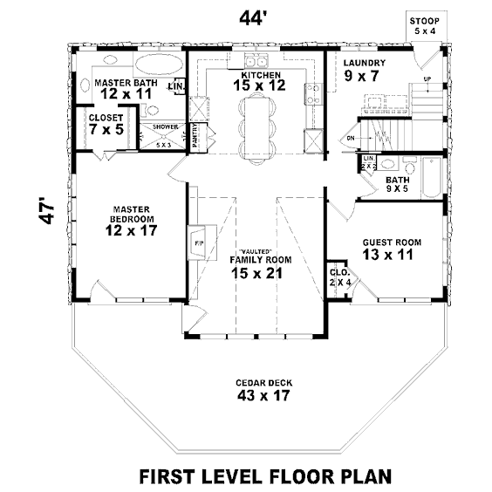

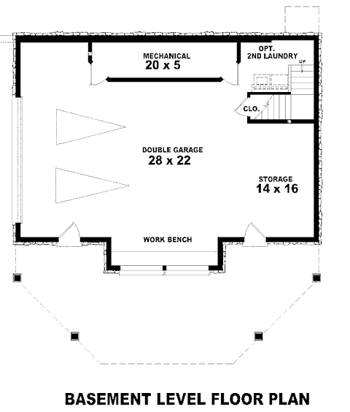
FEATURES
- loft / balcony
- suited for view lot
- grill deck/sundeck
- volume/vaulted ceiling
- peninsula/eating bar
- storage area
- unfinished/future space
- walk-in closet
- side-entry garage
- guest suite
- family room/keeping room
- garage under

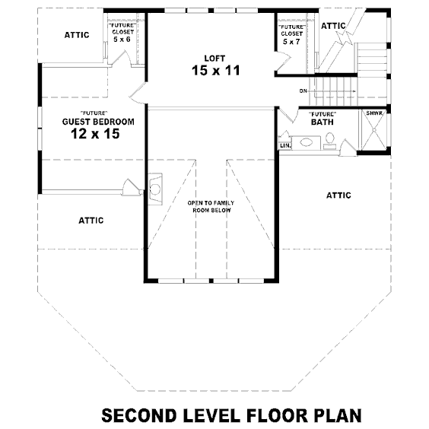

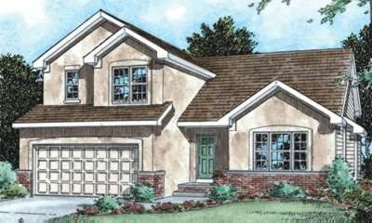
TRADITIONAL
PLAN 15-1120

1573 square feet
3 bedrooms
2 bathrooms
Double car garage
Width 42 feet
Depth 48 feet

Price

$359,000
Lot size: 82’ X 174’
14,268 square feet

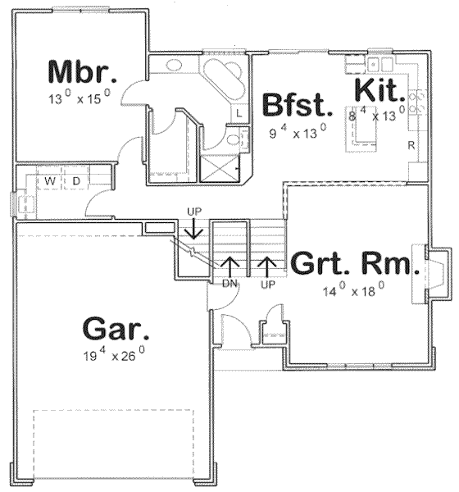
FEATURES
- covered front porch
- great room/living room
- unfinished basement
- walk-in closet
- peninsula/eating bar
- main floor master bed & bath
- suited for narrow lot
- nook/breakfast area/dining
- suited for corner lot
- open floor plan
- unlimited use

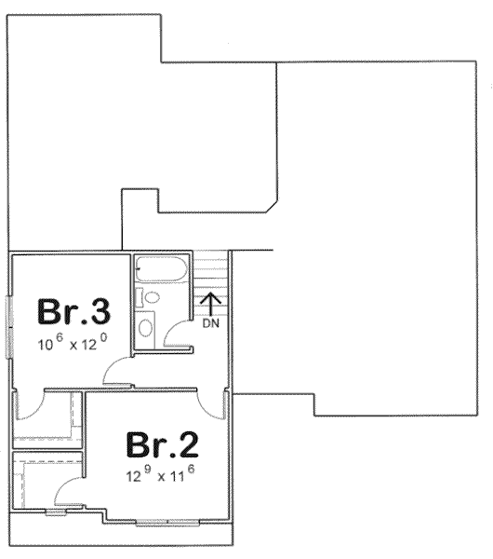

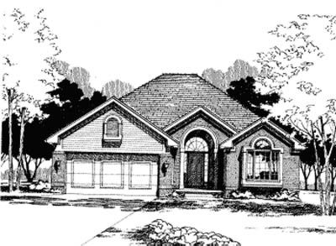
TRADITIONAL
PLAN 15-220

1636 square feet
3 bedrooms
2 bathrooms
Double car garage
Width 42 feet
Depth 60 feet

Price

$409,000
Lot size:
82’ X 174’
14,268 square feet

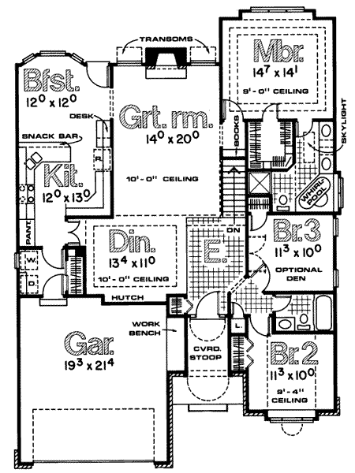
FEATURES
- great room/living room
- unlimited use
- suited for view lot
- walk-in closet
- volume/vaulted ceiling
- peninsula/eating bar
- suited for narrow lot
- nook/breakfast area/dining
- open floor plan

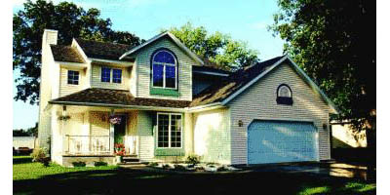
TRADITIONAL
PLAN 15-178

1650 square feet
3 bedrooms
2.5 bathrooms
Double car garage
Width 44 feet
Depth 40 feet

Price

$369,000
Lot size:
82’ X 174’
14,268 square feet

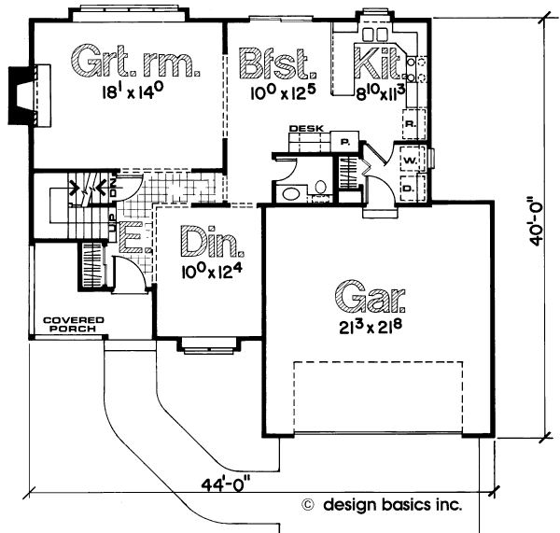
FEATURES
- covered front porch
- great room/living room
- suited for narrow lot
- suited for view lot
- walk-in closet
- nook/breakfast area/dining
- unfinished basement
- open floor plan
- peninsula/eating bar
- upstairs master bdrm
- unlimited use

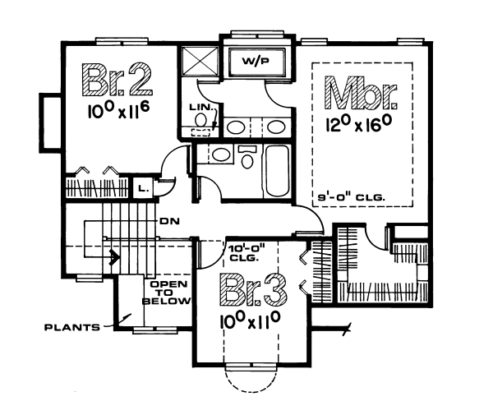

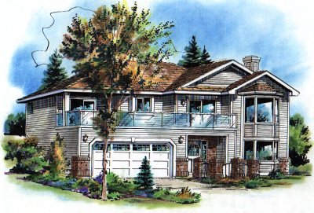
RANCH
PLAN 11-54

1767 square feet
4 bedrooms
2 bathrooms
Double car garage
Width 44 feet
Depth 37 feet

Price

$439,000
Lot size:
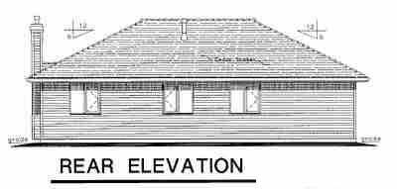
82’ X 174’
14,268 square feet

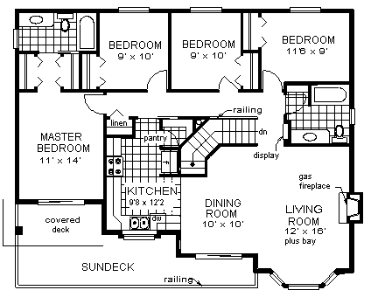

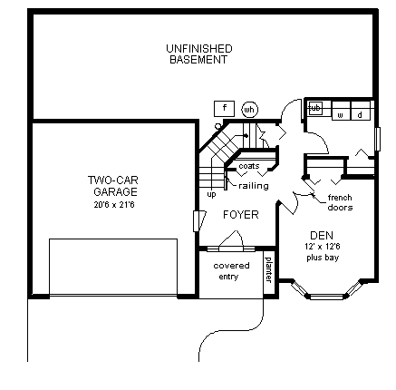
FEATURES
- suited for view lot
- inverted living
- unfinished/future space
- suited for narrow lot
- den/office/study/computer
- open floor plan
- walk-in pantry/cabinet pantry
- daylight basement

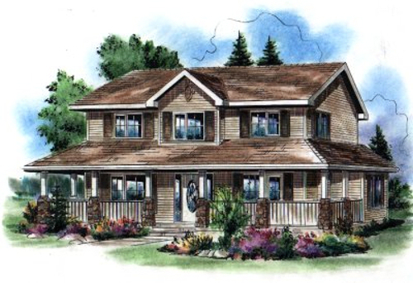
COUNTRY
PLAN 11-5

1779 square feet
4 bedrooms
3 bathrooms
Detached 2 car garage
Width 45 feet
Depth 38 feet

Price

$409,000
Lot size:
82’ X 174’
14,268 square feet

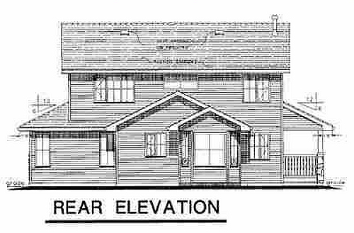

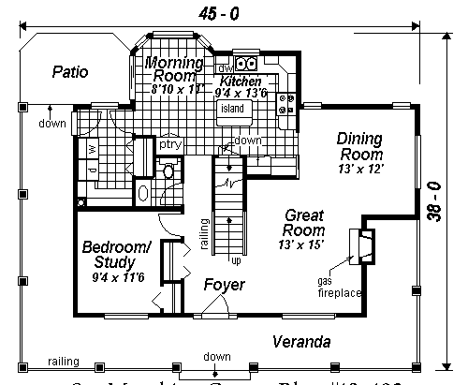

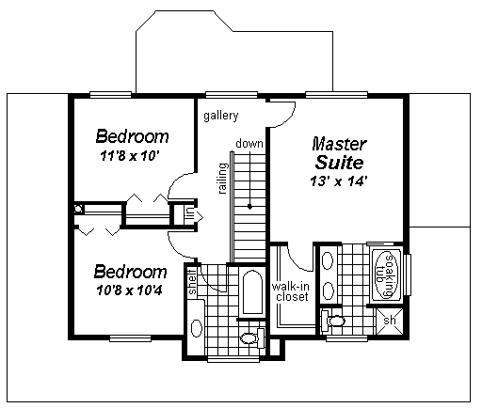
FEATURES
- den/office/study/computer
- great room/living room
- kitchen island
- suited for narrow lot
- suited for view lot
- walk-in closet
- unfinished/future space
- nook/breakfast area/dining
- unfinished basement
- wrap around porch
- upstairs master bdrm

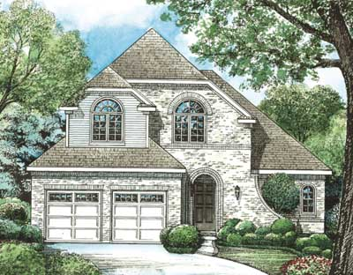
EUROPEAN
PLAN 15-1218

1780 square feet
3 bedrooms
2.5 bathrooms
Double garage
Width 42 feet
Depth 52 feet

Price

$389,000
Lot size: 82’ X 174’
14,268 square feet

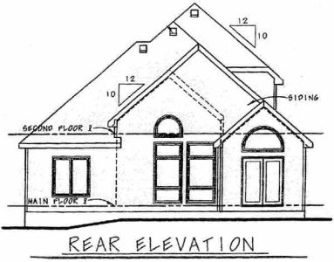

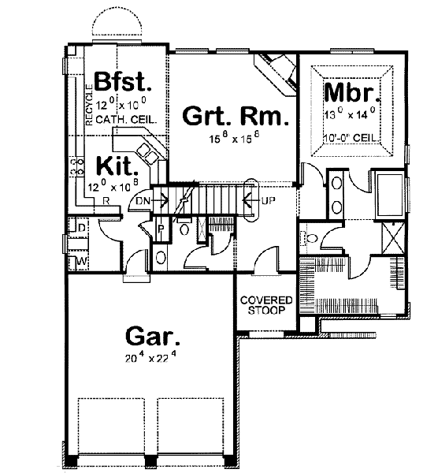
FEATURES
- great room/living room
- suited for view lot
- walk-in closet
- peninsula/eating bar
- volume/vaulted ceiling
- main floor master bed & bath
- suited for narrow lot
- open floor plan
- unlimited use

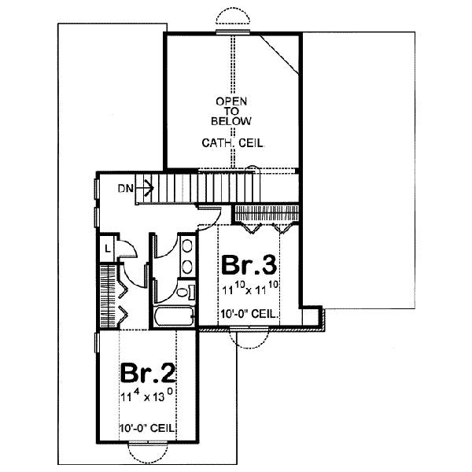

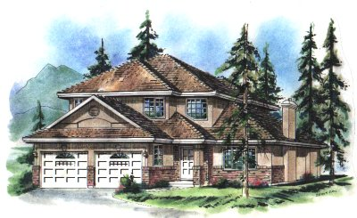
EUROPEAN
PLAN 11-138

1846 square feet
3 bedrooms
2.5 bathrooms
Double garage
Width 41 feet
Depth 48 feet

Price

$399,000
Lot size:
82’ X 174’
14,268 square feet
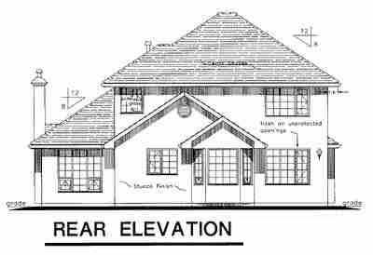

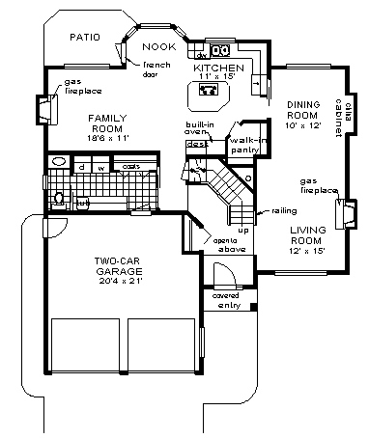
FEATURES
- kitchen island
- suited for narrow lot
- suited for view lot
- walk-in pantry/cabinet pantry
- family room/keeping room
- unfinished basement
- open floor plan
- volume/vaulted ceiling
- upstairs master bdrm

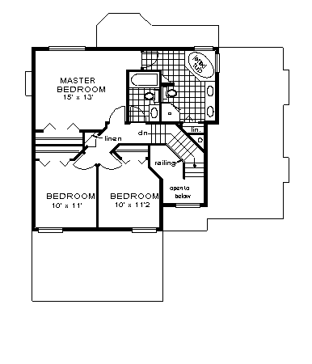

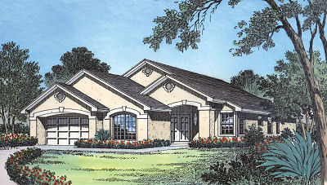
SUNBELT
PLAN 143-60

1890 square feet
4 bedrooms
2 bathrooms
Double garage
Width 45 feet
Depth 66 feet

Price

$459,000
Lot size:
82’ X 174’
14,268 square feet

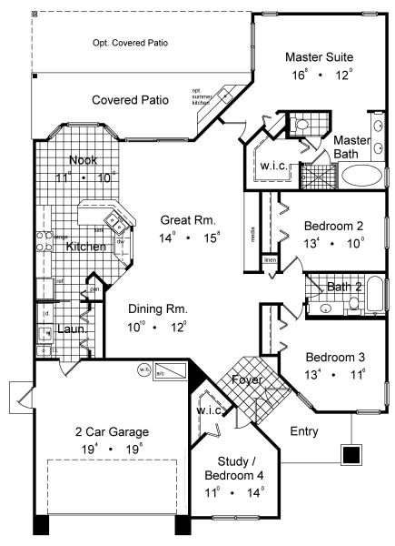
FEATURES
- covered front porch
- great room/living room
- covered rear porch
- walk-in closet
- volume/vaulted ceiling
- main floor master bed & bath
- peninsula/eating bar
- suited for narrow lot
- nook/breakfast area/dining
- suited for corner lot
- den/office/study/computer
- main floor bed & bath

