

Your Guide To Events and Activities At The Mall During The Summer of 2006

HANMER VALLEY SHOPPING CENTRE REMAINS COMMITTED TO GOAL OF BUILDING AND DEVELOPING STRONG COMMUNITY SPIRIT IN VALLEY EAST & CAPREOL
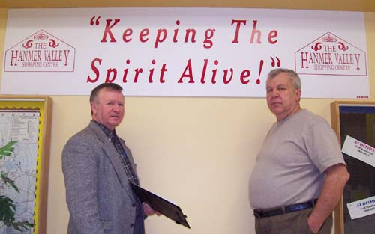
When it comes to “Keeping The Spirit Alive”, the Hanmer Valley Shopping Centre is quite clear that we remain committed to doing everything we can to build and develop the strong community spirit for which the towns of Valley East and Capreol were once famous.
In the photo to the right, Robert Kirwan, Director of Marketing & Public Relations of the Hanmer Valley Shopping Centre, and Marcel Servais, Chairman of the Valley East Lions Charity Days Committee, met recently to discuss details of their big community event which will be held on September 8 and 9, 2006.
When it comes to promoting and supporting community events, the mall merchants are always willing to do whatever they can.

LOCAL GROUPS INVITED TO USE COMMUNITY BULLETIN BOARD TO COMMUNICATE WITH THE PUBLIC
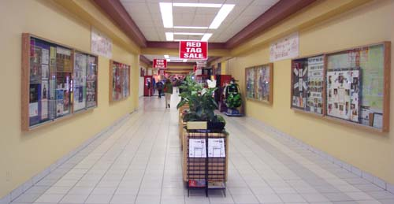
The community bulletin boards in the East Wing of the mall are being well used by members of groups, churches, schools and other organizations wishing to communicate with the general public. If you would like to post your information on the bulletin board, simply contact Robert Kirwan, Director of Marketing & Public Relations for the mall. You can contact him by phoning 524-7006 or by email at robert@kirwan.ca. This is a free public service being offered by the Hanmer Valley Shopping Centre in order to help promote local groups and organizations whose members are instrumental in helping “Keep The Spirit Alive” in Valley East and Capreol. Thousands of people look over those bulletin board displays every week.

CALENDAR OF EVENTS

The Hanmer Valley Shopping Centre is pleased to provide space for community groups and organizations for their fund-raising or public awareness activities. Since some groups book events at the last minute, it is always suggested that you check out our up to date Calendar of Events which can be found on the community web site by logging on to:
www.valleyeasttoday.ca
YOU CAN BOOK THE MALL FOR YOUR FUND-RAISING OR PUBLIC AWARENESS EVENT BY CALLING ROBERT KIRWAN AT 524-7006. We welcome all community groups and will even provide tables and chairs free of charge. The Hanmer Valley Shopping Centre is your community center – so feel free to use it to promote your activities and give recognition to your members.
BOOKINGS FOR THE FALL AND WINTER ARE NOW BEING ACCEPTED

Windows In Time Section Of Valley East Today Brings Back Fond Memories
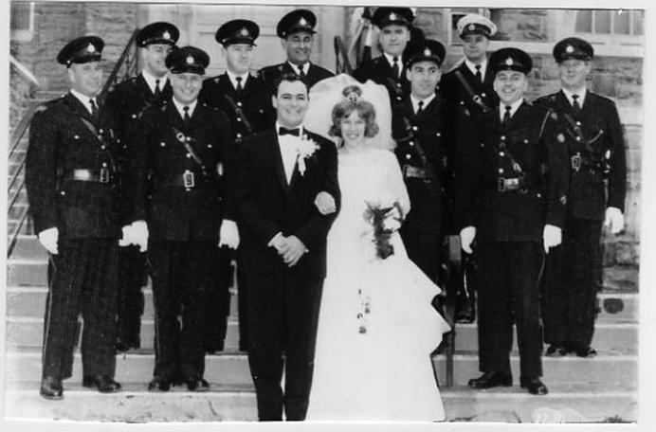

The photo above was taken on May 9, 1964 upon the occasion of the marriage of Joe Niceforo to Jean Pharand. The wedding took place at St. Jean de Brebeuf on Notre Dame Street in Sudbury. Ron Gladu Photos is sponsoring a special project through the Hanmer Valley Shopping Centre, called WINDOWS IN TIME. Residents are asked to bring in old photos and stories so that they can be posted on the Valley East Today web site for others to read. This is something that is being done to capture some of the history of our community and give recognition to the people who worked so hard in the early years to give Valley East and Capreol such a strong foundation upon which to grow. More information on this project can be found on the community bulletin board, or on the web site which can be found at www.valleyeasttoday.ca.
“THIS WEEK AT THE MALL”
Every Wednesday in
The Vision Paper

Make sure you check out our weekly column in The Vision Paper, “This Week At The Mall”! You will find it on Page 3, right beside Robert Kirwan’s editorial.
“This Week At The Mall” will provide you with up to date information about activities and special events that are taking place at the Hanmer Valley Shopping Centre during the coming week.
The mall has become the “unofficial community center” for Valley East as we are more than pleased to do what we can to help schools, churches, and other organizations serve the needs of the communities of Valley East and Capreol.
“This Week at the Mall” is a special service to the public and is sponsored by Val & Vi Mazzuca as well as the following merchants of the Hanmer Valley Shopping Centre. The merchants listed below are also sponsoring a promotional section of the community web site at www.valleyeasttoday.ca where they will be listing some of their weekly specials and hot deals. Each of the businesses will be featured in special articles every month which are designed to help you become more aware of the goods and services they are offering.
Check out the site often to make sure that you cash in on some of the best prices in the district.
Beswick Denture Clinic | Sole Mates Family Footwear
Valley Plaza Barber Shop | Hanmer Home Hardware
Pet Palace | The Source by Circuit City
Stan Thomas (Solicitor) | Desjardins’ Food Basics
The Cutting Boutique | Valley Computers
Drs. Dunlop & Labrecque | Hart Department Store
Lou’s Shoe Repair | Glamorous You Nail Salon
CHECK US OUT ONLINE AT
www.valleyeasttoday.ca
FOR OUR
ONLINE CATALOGUE OF VALUES

MAKE YOUR VOTE COUNT
Plan now to vote in the upcoming municipal election on November 13, 2006. Let’s show the rest of the City that Valley East cares!
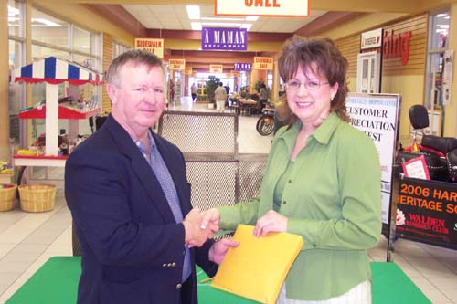


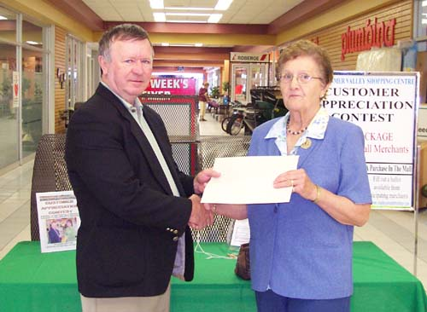

Many of the merchants of the Hanmer Valley Shopping Centre are sponsoring a very popular Customer Appreciation Contest at the mall. In the photo above, THERESE CAMPEAU receives her prize package from Robert Kirwan, Director of Marketing and Public Relations for the Hanmer Valley shopping Centre. THERESE was the winner for the month of May. SIMONE CHAISON, shown in the photo below was the winner of the March prize package.

Every time you make a purchase, you can either fill out your name and phone number on the back of your receipt and drop it in one of the two big ballot drums which are located at Desjardins’ Food Basics and Billie Jeans Fashions. A new winner will be drawn ever month.
For a complete listing of all of the prizes available each month, all you have to do is visit the Hanmer Valley Shopping Section of the Valley East Today Community Web Site by logging on to: www.valleyeasttoday.ca
The winner of the April Prize Package was Natalie Langlois, shown above receiving her winnings from Robert Kirwan.
Doug & Linda Beswick Recognized As International Leaders With Oxyfresh
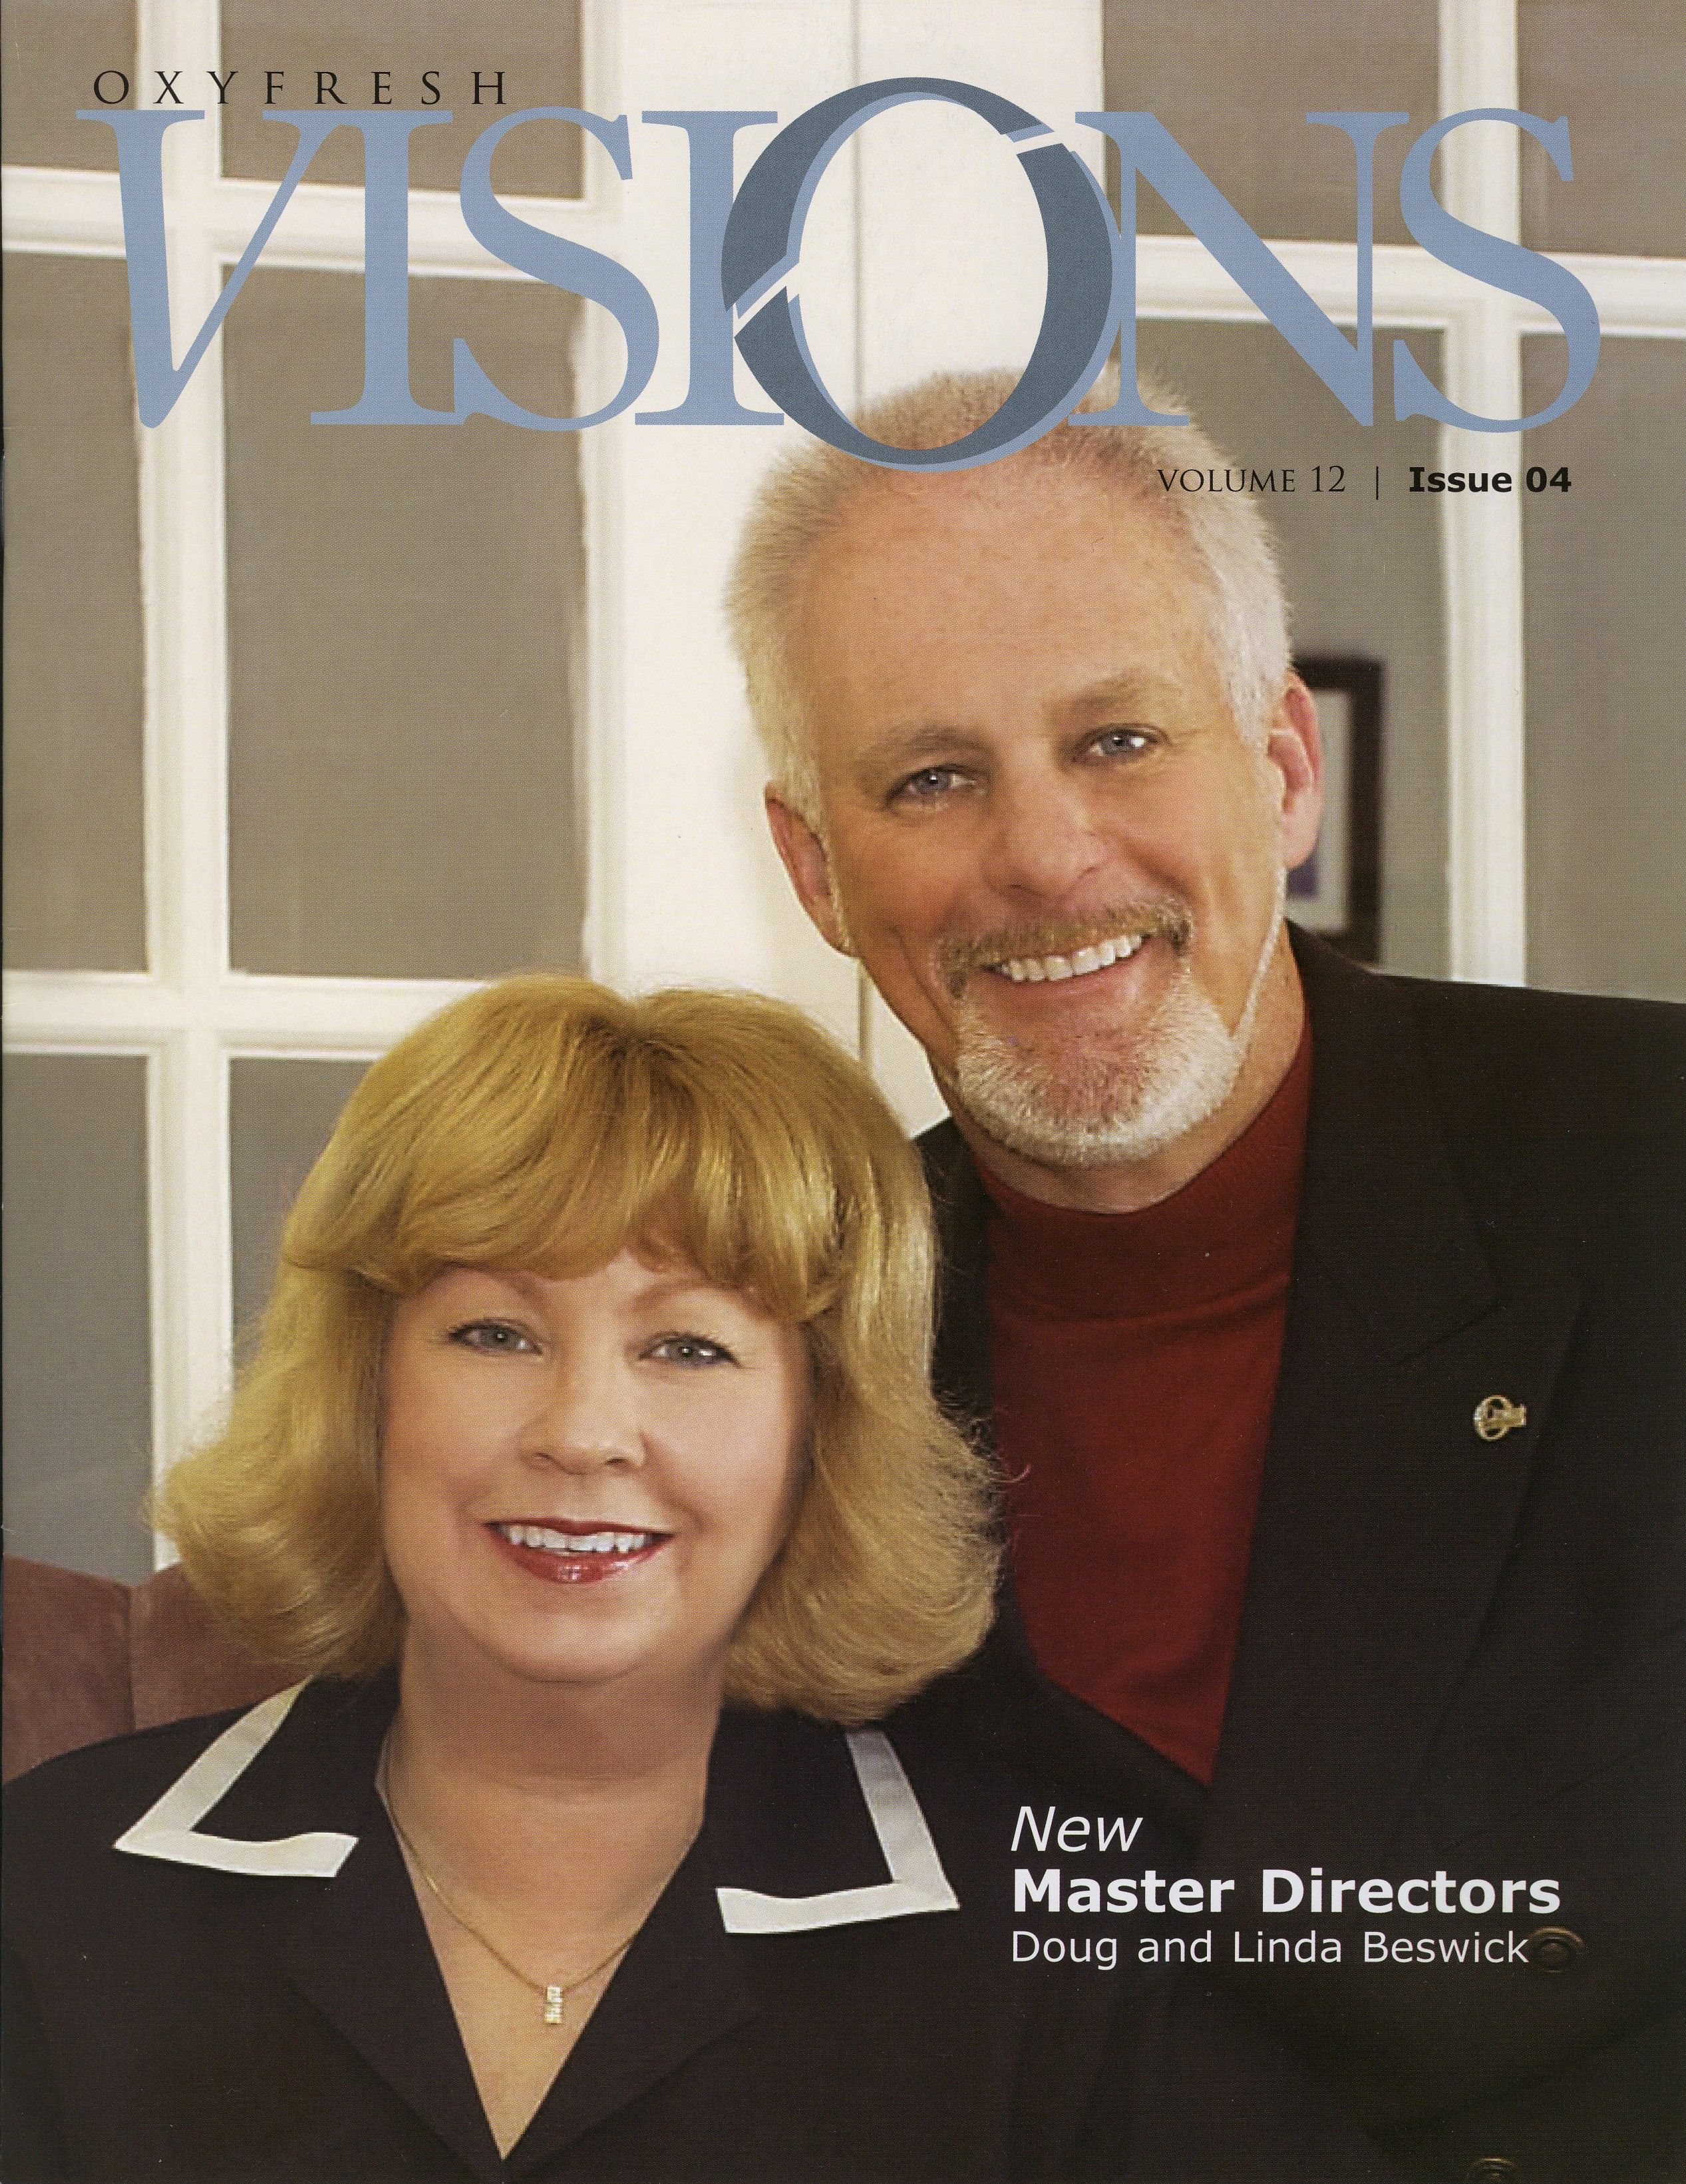
Doug and Linda Beswick have risen to success as Master Directors with Oxyfresh. They are responsible for the rapid growth of this organization in Ontario and indeed right across Canada. They were also featured on the cover of the company's international magazine. For Doug Beswick, the decision to become part of the Oxyfresh Organization was an easy one since he has been using the company products for some time now and is very pleased with the results experienced by his patients. The next time you are on the Valley East Today Community Web Site at www.valleyeasttoday.ca, make sure you log on to the Beswick web site section and take a tour of both of their offices which are located at the Hanmer Valley Shopping Centre and on Barrydowne Road.
ROBERT KIRWAN
CANDIDATE FOR COUNCILLOR OF WARD 6
SERVING HANMER & VAL THERESE
CAMPAIGN OFFICE AT THE
HANMER VALLEY SHOPPING CENTRE
www.kirwan.ca www.valleyeasttoday.ca
(705) 524-7006




VALLEY EAST’S MOST INFORMATIVE SOURCE OF COMMUNITY NEWS AND INFORMATION

Publisher of Valley East Today Seeks To Become Councillor of Ward 6 Representing Hanmer And Val Therese in November 2006 Municipal Election

Robert Kirwan, Publisher of the Valley East Today Online Weekly News Magazine and Community Web Site has announced that he will be entering the race to become Councillor of Ward 6 in the 2006 Municipal Election which will be held in November. Kirwan has lived in Val Therese since 1974 where he and his wife, Valerie have raised three sons who all attended St. Anne School in Hanmer. He was a teacher at St. Anne School for 23 years and has been involved with numerous groups and organizations over the years. Besides publishing Valley East Today, Kirwan is also the writer for The Vision Paper and has held the role of Marketing Manager for the Hanmer Valley Shopping Centre since March 2004. He is well-known for his promotion of Valley East.
There are many issues that Kirwan intends to tackle if he is successful in his bid to be elected to City Council, but by far his most important priority is to regain some of the community spirit and strength that Valley East was known for prior to amalgamation. “So much attention is being focused on the City of Greater Sudbury that everyone is forgetting about the outlying areas like Hanmer and Val Therese. We’ve given the current Council six years to get their act together, but things are just not working out. All of the promises of more efficiency, lower taxes and a stronger community are just not coming true. It is time for Council to try a different approach: one that concentrates on building strong communities within the City of Greater Sudbury. We need to improve the level of services and stimulate economic development in the outlying areas like Valley East, Rayside Balfour and Capreol. If the smaller communities are stronger, then the City of Greater Sudbury will be stronger.” Kirwan also intends to greatly improve the level of services we are now receiving.
Online Weekly News Magazine Being Emailed To An Estimated Audience of Up To 20,000 People

The Valley East Today Online Weekly News Magazine is being emailed every Tuesday to an estimated 15 - 20,000 different people each week. The power of the internet is remarkable! We have heard from people who have both received and forwarded the publication to dozens of others on their email address lists.
HUNDREDS OF PHOTOS
There are many reasons for the popularity of the publication. For one, it contains a large number of colour photos. Most of the feature articles include one or more photos of people who are instrumental in carrying out a wide variety of initiatives. These photos generate a great deal of interest among friends and acquaintances who then forward the articles and hence the web site to people all over the world.
ARTICLES REMAIN ONLINE INDEFINITELY
Another feature of the online publication is that the articles and information sections remain on the site indefinitely. Once you find something you like, you know it will be there the next time you return to the site. There is no plan to take anything off of the site which simply continues to grow and grow to massive proportions.
WEB SITE CAPTURES SPIRIT OF VALLEY EAST
Perhaps the most exciting thing about the community web site and the weekly online news magazine is that residents now have one central place which captures the essence and the spirit of Valley East. Whenever anyone asks you to tell them about Valley East, all you have to do is refer then to the web site at www.valleyeasttoday.ca and they will find out everything there is to know about this community.
www.valleyeasttoday.ca
Robert Kirwan – Publisher
Office at the Hanmer Valley Shopping Centre
Phone: (705) 524-7006
Email: robert@kirwan.ca

